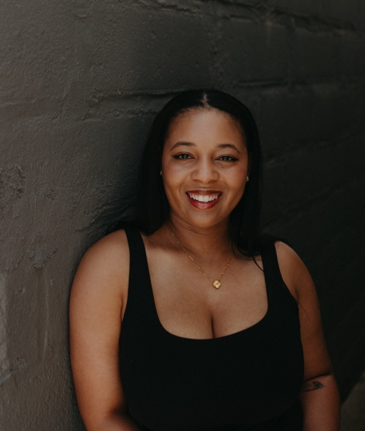
RANGE: G3-A5
LANSING, MI
810-391-3265
ARIBROWN2799@GMAIL.COM
Ari Brown

CREDITS

COMMERCIAL
- Nothing Bundt Cakes | Ensemble Actor | BrandHRT

PRINT
- Student Model | Ensemble | Michigan State University

THEATER
- Bat Boy: the Musical | Reverend Hightower/Ensemble | Columbia College Chicago
- The Wiz | Auntie Em | POC Productions
- Leap of Faith | Ornella | Flint Community Players
- Dreamgirls | Ensemble/US Deena | Arts Collective Theatre
- In The Heights | Vanessa | The Spotlight Project
- Urinetown | Ensemble/Mrs. Millennium | Flint Community Players

TRAINING

Columbia College Chicago; Chicago, IL — B.A. Musical Theatre
Sep 2019 - May 2023
“Energetic and collaborative performer. Sharp comedic instincts and a grounded emotional range. A gifted and authentic storyteller, blending strong vocals, vulnerability, and movement.” -

SPECIAL SKILLS
Beginner guitar, accents and dialects, rapping, swimming, pole dancing, cooking, baking, Spanish

